AI MEETING MINUTES GENERATOR

Final Group Project Report
BIT 4543 — Artificial Intelligence

Project Topic: AI Meeting Minutes Generator
AI Topic: Speech-to-Text + Text Generation

Submission Date: 06/09/2026

STUDENT NAME | STUDENT ID
Faiza Malik | 2507 1844
Sangkari Maniyarasu | 2503-0675
Ridhwan Mahamud Arpon | 2507-1809
Ahmed Estayak | 2507-1924

Executive Summary
The AI Meeting Minutes Generator is a Generative AI application designed to reduce the time and effort required to prepare meeting minutes. The project addresses the practical problem of manually reviewing meeting recordings, identifying important discussion points, summarizing the meeting, and recording follow-up tasks.
The system combines two main AI capabilities: Speech-to-Text and Text Generation. A meeting recording is provided as input, converted into a transcript, and then processed by a text-generation model to produce structured meeting minutes. The intended output includes a meeting summary, key discussion points, decisions, and action items where these are supported by the transcript.
The project demonstrates how AI can automate a repetitive document-preparation workflow while maintaining a clear and readable final output. The final implementation, model choices, data sources, testing evidence, screenshots, and measured performance should reflect the technologies and results actually achieved by the group.

1. Introduction
Meeting minutes provide a record of important discussions, decisions, responsibilities, and follow-up activities. Preparing them manually can be time-consuming, especially when the meeting is long or the recorder must replay sections to identify the most relevant information.
The AI Meeting Minutes Generator applies Artificial Intelligence to this process by combining speech recognition with text generation. Speech recognition converts spoken language into a written transcript, while text generation analyses the transcript and produces a structured version of the meeting minutes.
For BIT 4543 Artificial Intelligence, the selected project is the AI Meeting Minutes Generator. The project falls under the Speech-to-Text + Text Generation topic and is intended to produce a Smart Meeting Assistant.

2. Problem Statement
Meeting participants can spend substantial time preparing minutes after a meeting. The task may require replaying recordings, transcribing conversations, identifying key points and decisions, determining action items, and formatting the final document. Manual preparation can also result in inconsistent summaries or missed tasks.
The proposed system addresses this problem by automating the main stages of the workflow, from audio transcription to the generation of structured meeting minutes.

3. Project Objectives
- Convert meeting audio into a readable text transcript.
- Generate a concise and meaningful summary of the meeting.
- Extract relevant action items from the meeting content.
- Present the generated information in a structured and user-friendly format.
- Demonstrate the practical integration of Speech-to-Text and Text Generation AI.

4. Project Scope
The project focuses on an end-to-end workflow that accepts a meeting recording and produces useful meeting minutes.
- Audio input through a user-friendly upload interface.
- Speech-to-Text conversion of the meeting recording.
- Transcript preparation for downstream AI processing.
- AI-based meeting summarization.
- Action-item extraction from the transcript.
- Structured presentation of the generated minutes.
- A simple user flow from recording input to final output.
Advanced capabilities such as speaker identification, calendar integration, real-time transcription, enterprise authentication, and multilingual support are treated as extensions unless they are part of the group's implemented system.

5. AI Concepts Used
Actual AI Model Used
AI Model / Technology Used:
Speech-to-Text: OpenAI Whisper
Text Generation: OpenRouter API – OpenRouter Free Models Router (openrouter/free)
Application Interface: Streamlit
Programming Language: Python

5.1 Speech-to-Text
Speech-to-Text (STT) converts spoken language from an audio recording into written text. In this project, STT is the first major AI stage because the meeting audio must be converted into a transcript before the content can be summarized or analyzed.

5.2 Text Generation and Summarization
Text generation transforms the transcript into a concise and organized representation of the meeting. Prompt-based instructions can guide the model to focus on important discussion points, decisions, conclusions, and follow-up activities.

5.3 Information Extraction
Information extraction identifies specific information from the transcript and organizes it into a structured form. For this project, the main target is action-item extraction. An action item may include the task, an assigned person when explicitly stated, and a deadline when explicitly stated.
The system should remain grounded in the transcript and avoid inventing names, dates, responsibilities, decisions, or other information that is not supported by the source content.

6. Methodology
The project follows a pipeline-based methodology. Each processing stage produces the information required by the next stage, allowing the workflow to move from raw meeting audio to structured meeting minutes.
Step | Stage | Description
1 | Audio Input | Upload or provide a meeting recording.
2 | Audio Preparation | Prepare the recording for the selected speech-recognition service or model when necessary.
3 | Speech Recognition | Convert the recording into a text transcript.
4 | Transcript Processing | Clean, normalize, or prepare the transcript for text generation when required.
5 | Prompt Preparation | Provide the transcript and structured instructions to the text-generation component.
6 | Generation & Extraction | Generate the meeting summary and identify action items.
7 | Result Presentation | Display the generated minutes in the application.
8 | Testing | Evaluate functionality, output quality, usability, and handling of difficult inputs.

7. System Architecture
The application architecture can be viewed as three connected layers: an input layer, an AI processing layer, and an output layer. The exact libraries, models, APIs, and deployment technologies should match the group's implementation.
Component | Function | Implementation
Audio Input | Accept meeting recordings | Web upload interface
Speech-to-Text | Convert audio to transcript | OpenAI Whisper (base model)
Transcript Processing | Clean and prepare transcript | Audio was provided directly to wishper for transcription.
Text Generation | Summarize meeting content | OpenRouter API using OpenRouter Free Models Router
Action Extraction | Identify follow-up tasks | Prompt-based extraction using the LLM
Application UI | Display results | Streamlit
Storage | Store files/results when implemented | Not implemented

8. AI Model Implementation
The AI implementation combines Speech-to-Text and Text Generation. The speech-recognition component produces the transcript, and the text-generation component interprets the transcript to create structured meeting minutes.

8.1 Prompt Engineering

The text-generation prompt should clearly define the task, provide the transcript, and specify the required output structure. A structured format improves consistency and makes the generated result easier to review.
- Meeting Summary
- Key Discussion Points
- Decisions Made
- Action Items
- Assigned Person — only when explicitly identifiable
- Deadline — only when explicitly stated
The prompt should instruct the model to rely only on the supplied transcript. Unsupported names, deadlines, decisions, or responsibilities should not be created by the model.
8.2 AI Techniques Used
1. Speech-to-Text (STT)
Converts the uploaded meeting audio into a text transcript using OpenAI Whisper (base model).
2. Text Generation
Uses a Large Language Model through the OpenRouter API to analyze the transcript and generate meeting minutes such as summaries, discussion points, and decisions.
3. Prompt Engineering
Structured prompts are provided to the language model to control what information it should generate from the transcript.
4. Information / Action-Item Extraction
The LLM identifies follow-up tasks from the transcript and extracts information such as the task, responsible person when explicitly identifiable, and deadline when stated.
8.3Tools and Technologies Used
Tool / Technology | Purpose
Python | Main programming language
OpenAI Whisper | Speech-to-text transcription
OpenRouter API | Access to the text-generation model
OpenRouter Free Models Router | Routes requests to available free LLMs
Streamlit | Web application interface
ElevenLabs | Generated synthetic meeting audio for testing
FFmpeg | Audio processing required by Whisper
GitHub | Version control and project repository
VS Code | Code development environment

9. Application Development
The application is designed around a simple end-to-end workflow. The user provides a meeting recording, the system processes the recording, and the generated minutes are presented for review.

9.1 Core User Flow

- Open the Smart Meeting Assistant.
- Upload or select a meeting audio file.
- Start the processing workflow.
- Review the transcript when the interface provides it.
- Review the generated meeting summary.
- Review the extracted action items.
- Review the final generated meeting minutes in the application.

9.2 Main Interface Screens

- Home/Input screen — audio upload and processing control.
- Processing state — progress or loading feedback.
- Results screen — summary, discussion points, decisions, and action items.
- Transcript view — optional full Speech-to-Text output.

10. Data Collection and Preparation
The assignment brief does not prescribe a single dataset for the AI Meeting Minutes Generator. Therefore, the report should document the actual meeting recordings or sample data used by the group.
Data source | ___ Sample meeting audio generated using ElevenLabs Text-to-Speech_________________________________________
Number of audio samples | __1__________________________________________
Audio formats | __ MP3__________________________________________
Average / maximum duration | ____1mint16sec________________________________________
Language(s) | ____ English________________________________________
Preprocessing | ________ Audio was provided directly to the Whisper speech-to-text model for transcription____________________________________
Privacy / consent procedure | ____________ Synthetic/sample audio was used for testing; no real personal meeting recording was used________________________________

11. Testing and Evaluation
Testing verifies that the core application functions operate as intended and that the generated content is useful and based on the meeting transcript.
Test Case | Input | Expected Result | Actual Result / Evidence
Audio upload | Valid meeting audio | File is accepted and processing can begin | Passed – The MP3 meeting audio was successfully uploaded and processing started.
Speech-to-Text | Meeting recording | Readable transcript is generated | Passed – The meeting audio was successfully converted into a readable transcript using Whisper.
Summary generation | Valid transcript | Concise and relevant summary is produced | Passed – A concise meeting summary was successfully generated from the transcript.
Action extraction | Transcript containing tasks | Relevant action items are identified | Passed – Relevant action items and deadlines were successfully identified from the transcript.
Empty / invalid input | Unsupported or empty file | Clear error message is displayed | Not tested – No empty or invalid input test was performed.
Long recording | Longer meeting audio | System processes it or clearly handles its limit | Not tested – No long recording test was performed.

11.1 Evaluation Criteria

- Transcription accuracy and readability.
- Summary relevance and conciseness.
- Correctness of extracted action items.
- Ability to avoid unsupported details.
- Processing time and system responsiveness.
- Usability of the interface.
- Stability when handling invalid or difficult inputs.

12. Results
The results section should present evidence from the completed prototype and testing process. Numerical performance values should be based on actual measurements rather than estimates.

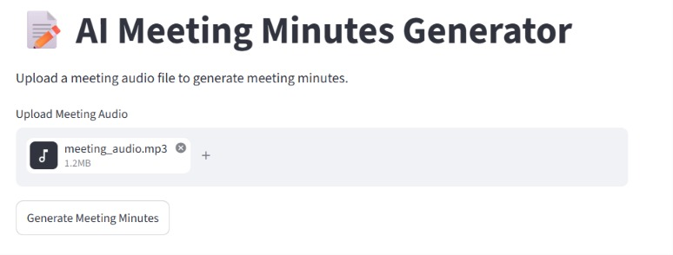 Audio upload screen

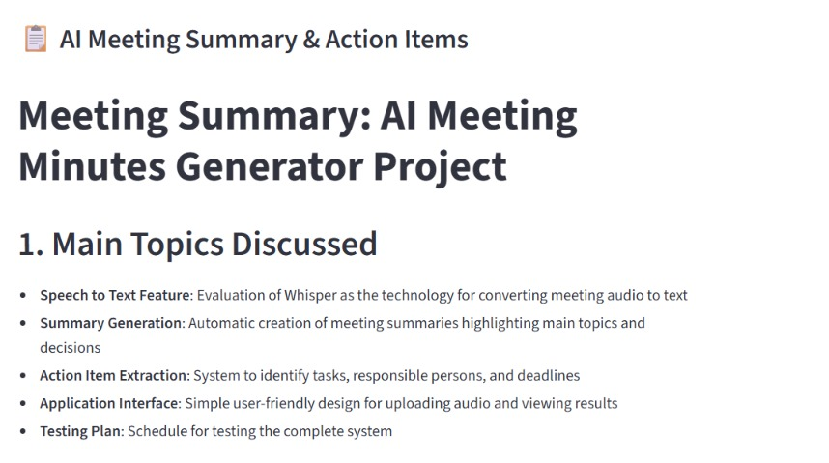
Speech-to-Text Result

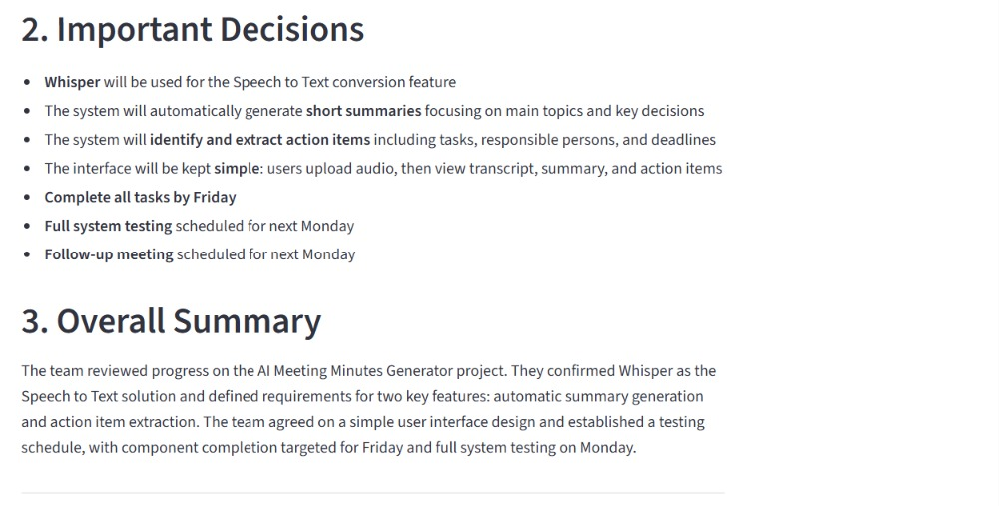Summary Generation
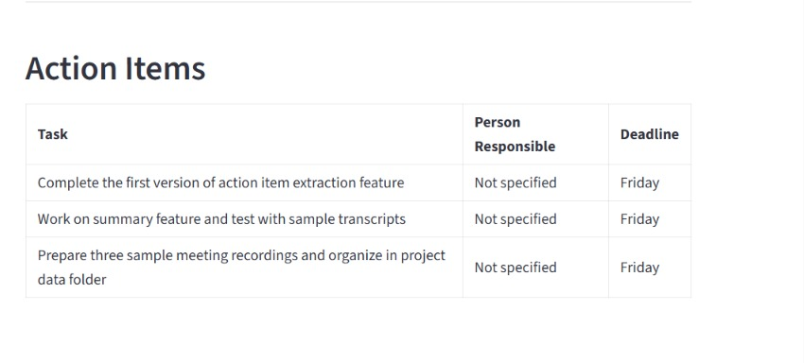Action Item Extraction

13. GitHub Repository Structure
The repository should maintain a clear structure so that source code, data, models, documentation, test files, and results can be located easily.
project-name/
├── data/
├── notebooks/
├── src/
├── app/
├── models/
├── docs/
├── results/
├── tests/
├── README.md
├── requirements.txt
├── LICENSE
└── .gitignore
GitHub Repository: ______________________________________________

14. Project Timeline
Week | Activities | Deliverable
Week 1 | Problem definition, literature review, data/document collection, GitHub setup | Project Proposal
Week 2 | Prompt engineering, API integration, knowledge base preparation, initial prototype | Progress Report
Week 3 | Front-end development, AI workflow integration, core feature testing | Prototype Demo
Week 4 / Week 6 | User testing, performance evaluation, documentation, presentation preparation | Final Application + Report + Slides
Week 5 / Week 7 | Presentation | Presentation & Demo

15. Limitations
- Speech-recognition quality may decrease because of background noise, overlapping speakers, accents, or poor audio quality.
- Generated summaries depend on the quality and completeness of the transcript.
- The text-generation model may omit minor details or misunderstand ambiguous statements.
- Action-item extraction can be difficult when responsibilities or deadlines are implied rather than explicitly stated.
- Long recordings may increase processing time and model or API usage.
- Meeting recordings may contain personal or confidential information, so privacy and consent must be considered.

16. Future Enhancements
- Speaker identification and speaker-labelled transcripts.
- Real-time meeting transcription.
- Automatic detection of decisions and unresolved questions.
- Calendar integration for meeting metadata and deadlines.
- Export to PDF, DOCX, email, or task-management systems.
- Multilingual transcription and summarization.
- User accounts and secure meeting-history storage.
- Custom summary templates for academic, business, or project meetings.

17. Conclusion
The AI Meeting Minutes Generator provides a practical approach to reducing the time required to prepare meeting minutes. By combining Speech-to-Text with Text Generation, the proposed Smart Meeting Assistant can transform meeting audio into a transcript, summarize the discussion, and identify action items.
The project demonstrates the integration of multiple AI capabilities within a single application and provides a clear example of how Generative AI can support routine document-preparation tasks. The final report should be supported by the completed prototype, model implementation, testing evidence, repository, screenshots, and presentation.

18. Assessment Rubric Alignment
Component | Marks | Report Section
Proposal | 10 | Sections 1–4
Dataset & Preparation | 10 | Section 10
AI Model Implementation | 25 | Sections 5, 6 and 8
Application Development | 20 | Section 9
Testing & Evaluation | 10 | Section 11
GitHub Repository Quality | 10 | Section 13
Final Report | 10 | Complete report
Presentation & Demo | 5 | Timeline, screenshots and live prototype

References

1.OpenAI. (n.d.). Whisper. GitHub.
https://github.com/
openai/whisper

2.OpenRouter. (n.d.). OpenRouter documentation.
https://openrouter.ai/
docs

3.Streamlit. (n.d.). Streamlit documentation.
https://docs.streamlit.
io/

4.Radford, A., Kim, J. W., Xu, T., Brockman, G., McLeavey, C., & Sutskever, I. (2023). Robust speech
recognition via large-scale weak supervision. Proceedings of the 40th International Conference on
Machine Learning, 202, 28492–28518.
https://proceedings.mlr.press
/v202/radford23a.html

